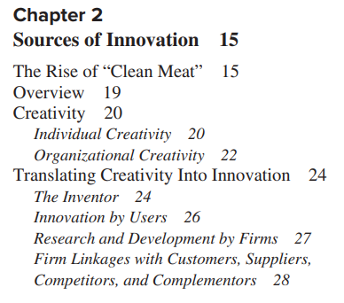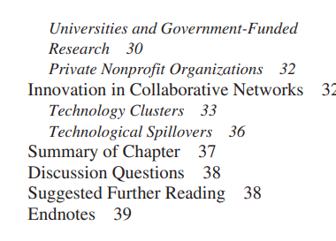

1. Creativity is the underlying process for innovation. Creativity enables individuals and organizations to generate new and useful ideas. Creativity is considered a function of intellectual abilities, knowledge, thinking styles, personality traits, intrinsic motivation, and environment.

2. Innovation sometimes originates with individual inventors. The most prolific inventors tend to be trained in multiple fields, be highly curious, question previously made assumptions, and view all knowledge as unified. The most wellknown inventors tend to have both inventive and entrepreneurial traits.

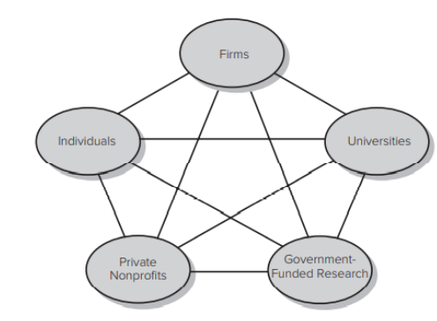

3. Innovation can also originate with users who create solutions to their own needs.

4. Firms’ research and development is considered a primary driver of innovation. In most countries, firms spend significantly more on R&D than government institutions spend on R&D, and firms consider their in-house R&D their most important source of innovation.

5. Firms often collaborate with a number of external organizations (or individuals) in their innovation activities. Firms are most likely to collaborate with customers, suppliers, and universities, though they also may collaborate with competitors, producers of complements, government laboratories, nonprofit organizations, and other research institutions.

6. Many universities have a research mission, and in recent years universities have become more active in setting up technology transfer activities to directly commercialize the inventions of faculty. Universities also contribute to innovation through the publication of research findings.

7. Government also plays an active role in conducting research and development (in its own laboratories), funding the R&D of other organizations, and creating institutions to foster collaboration networks and to nurture start-ups (e.g., science parks and incubators). In some countries, government-funded research and development exceeds that of industry-funded research.

8. Private nonprofit organizations (such as research institutes and nonprofit hospitals) are another source of innovation. These organizations both perform their own R&D and fund R&D conducted by others.

1. 创造力是创新的基础过程。 创造力使个人和组织能够产生新的、有用的想法。 创造力被认为是智力、知识、思维方式、个性特征、内在动机和环境的函数。

2. 创新有时源自个人发明家。 最多产的发明家往往接受过多个领域的培训，具有高度的好奇心，质疑先前做出的假设，并将所有知识视为统一的。 最知名的发明家往往同时具有发明和创业的特质。

3. 创新也可以源于根据自己的需求创建解决方案的用户。

4. 企业的研发被认为是创新的主要驱动力。 在大多数国家，企业在研发上的支出远远高于政府机构在研发上的支出，并且企业将内部研发视为最重要的创新来源。

5. 公司在创新活动中经常与许多外部组织（或个人）合作。 企业最有可能与客户、供应商和大学合作，尽管它们也可能与竞争对手、补品生产商、政府实验室、非营利组织和其他研究机构合作。

6. 许多大学都有研究使命，近年来，大学更加积极地开展技术转让活动，直接将教师的发明商业化。 大学还通过发表研究成果为创新做出贡献。

7. 政府还在开展研究和开发（在自己的实验室中）、资助其他组织的研发以及创建机构以促进合作网络和培育初创企业（例如科学园和孵化器）方面发挥积极作用。 在一些国家，政府资助的研究和开发超过了行业资助的研究。

8. 私人非营利组织（例如研究机构和非营利医院）是创新的另一个来源。 这些组织既进行自己的研发，又资助其他组织进行的研发。

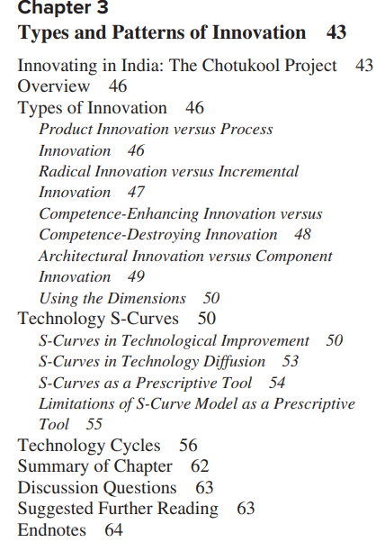

1. Different dimensions have been used to distinguish types of innovation. Some of the most widely used dimensions include product versus process innovation, radical versus incremental innovation, competence-enhancing versus competence destroying innovation, and architectural versus component innovation.

2. A graph of technology performance over cumulative effort invested often exhibits an s-shape curve. This suggests that performance improvement in a new technology is initially difficult and costly, but, as the fundamental principles of the technology are worked out, it then begins to accelerate as the technology becomes better understood, and finally diminishing returns set in as the technology approaches its inherent limits.

3. A graph of a technology’s market adoption over time also typically exhibits an s-shape curve. Initially the technology may seem uncertain and there may be great costs or risks for potential adopters. Gradually, the technology becomes more certain (and its costs may be driven down), enabling the technology to be adopted by larger market segments. Eventually the technology’s diffusion slows as it reaches market saturation or is displaced by a newer technology.

4. The rate at which a technology improves over time is often faster than the rate at which customer requirements increase over time. This means technologies that initially met the demands of the mass market may eventually exceed the needs of the market. Furthermore, technologies that initially served only low-end customers (segment zero) may eventually meet the needs of the mass market and capture the market share that originally went to the higher-performing technology.

5. Technological change often follows a cyclical pattern. First, a technological discontinuity causes a period of turbulence and uncertainty, and producers and consumers explore the different possibilities enabled by the new technology. As producers and customers begin to converge on a consensus of the desired technological configuration, a dominant design emerges. The dominant design provides a stable benchmark for the industry, enabling producers to turn their attention to increasing production efficiency and incremental product improvements. This cycle begins again with the next technological discontinuity.

6. The first design based on the initial technological discontinuity rarely becomes the dominant design. There is usually a period in which firms produce a variety of competing designs of the technology before one design emerges as dominant.

7. The dominant design rarely embodies the most advanced technological features available at the time of its emergence. It is instead the bundle of features that best meets the requirements of the majority of producers and customers.

Platforms and incentives for consensus building on complex ICT systems: The development of WiFi

Geerten van de Kaa, Hans de Bruijn

This paper illustrates the organizational hiccups that occurred during the development of IEEE 802.11. Various **incentives for consensus** building around IEEE 802.11 were discussed. The paper attempts to explain why actors remain committed or became even more committed towards the successful development of the platform in spite of numerous glitches in the platform development process. This paper suggests that the understanding of platform development is enriched by applying the **lens of governance and change management.**

The following recommendations have been formulated on the basis of the analysis:

1.

Important conflicts of interest are always involved whenever committees develop common ICT platforms. This means focus should not only be directed at the content of developing platforms but also at the decision-making process.

2.

The decision making process will partly emerge spontaneously, although it can also be designed.

3.

When designing this decision making process, it is important to ensure there are sufficient incentives for the participants to take part in the process (voice), to continue to participate, and to reach a (majority) consensus. Examples of such incentives include a **prospect of future gain, a prospect of enduring gain and a sense of urgency.** It is also important for losers in one round to have a new prospect of gain in subsequent rounds.

4.

Not all forms of governance need to be based on interaction and consensus. There is also space for **smart hierarchical interventions**, for example through procedure management: voting rules can be imposed upon participants, thus providing them with space while also giving direction to the process. These kinds of smart hierarchical interventions can be used to prevent the disadvantages associated with decision-making processes based exclusively on interaction and consensus.

5.

Governance within a network implies considerable space for emergence. It is difficult to predict which parties will participate and with which level of commitment, which issues they will bring to the table, which connections will emerge between issues, and which outcomes these connections will generate. The knowledge that such emergence is inherent to networks reinforces the importance of paying attention to the process and to its design. A well-designed process can ensure that the variation generated by emergence will also lead to selection and closure in decision making.

本文说明了 IEEE 802.11 开发过程中发生的组织问题。 讨论了围绕 IEEE 802.11 建立共识的各种**激励措施**。 本文试图解释尽管平台开发过程中存在许多问题，但参与者仍然致力于或更加致力于平台的成功开发。 本文建议通过**应用治理和变更管理**的视角来丰富对平台开发的理解。

在分析的基础上提出了以下建议：

1.每当委员会开发通用 ICT 平台时，总会涉及重要的利益冲突。 这意味着重点不应仅针对开发平台的内容，还应针对决策过程。

2.决策过程将部分自发出现，但也可以设计。

3.在设计这个决策过程时，重要的是要确保有足够的激励让参与者参与到这个过程中（发言权），继续参与，并达成（多数）共识。 这种激励的例子包括**未来收益的前景、持久收益的前景和紧迫感**。 对于在一轮中失败的人来说，在随后的几轮中有新的收获前景也很重要。

4.并非所有形式的治理都需要基于互动和共识。 **智能分层干预**也有空间，例如通过程序管理：投票规则可以强加给参与者，从而为他们提供空间，同时也为流程提供方向。 这些类型的智能分层干预可用于防止与完全基于交互和共识的决策过程相关的缺点。

5.网络内的治理意味着相当大的出现空间。 很难预测哪些各方将参与，承诺程度如何，他们将提出哪些问题，问题之间会出现哪些联系，以及这些联系将产生哪些结果。 这种出现是网络固有的知识加强了关注过程及其设计的重要性。 一个设计良好的过程可以确保因出现而产生的变异也将导致决策制定中的选择和收敛。

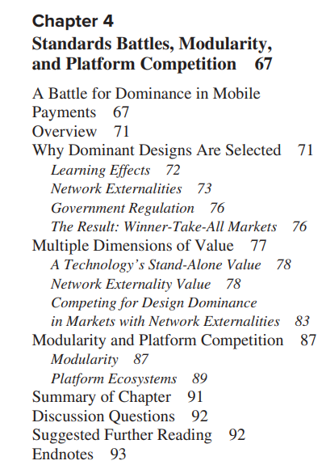

1. Many technologies demonstrate increasing returns to adoption, meaning that the more they are adopted, the more valuable they become.

2. One primary source of increasing returns is learning-curve effects. The more a technology is produced and used, the better understood and developed it becomes, leading to improved performance and reduced costs.

3. Another key factor creating increasing returns is network externality effects. Network externality effects arise when the value of a good to a user increases with the size of the installed base. This can be due to a number of reasons, such as need for compatibility or the availability of complementary goods.

4. In some industries, the consumer welfare benefits of having a single standard have prompted government regulation, such as the European Union’s mandate to use the GSM cellular phone standard.

5. Increasing returns can lead to winner-take-all markets where one or a few companies capture nearly all the market share.

6. The value of a technology to buyers is multidimensional. The stand-alone value of a technology can include many factors (productivity, simplicity, etc.) and the technology’s cost. In increasing returns industries, the value will also be significantly affected by the technology’s installed base and availability of complementary goods.

7. Customers weigh a combination of objective and subjective information. Thus, a customer’s perceptions and expectations of a technology can be as important as (or more important than) the actual value offered by the technology.

8. Firms can try to manage customers’ perceptions and expectations through advertising and public announcements of preorders, distribution agreements, and so on.

9. The combination of network externality returns to market share and technological utility will influence at what level of market share one technology will dominate another. For some industries, the full network externality benefits are attained at a minority market share level; in these industries, multiple designs are likely to coexist.

10. In markets where customers have heterogeneous preferences and there are many potential technological options available, firms might use modularity to enable customers to mix and match components, producing a wider array of end products.

11. Platform ecosystems are an example of modularity in action. A stable core platform (e.g., a smartphone operating system) may mediate the relationship between many complements producers (e.g., applications developers) and end users.

# Standardization for platform ecosystems

* [Geerten van de Kaa](https://link.springer.com/article/10.1007/s12525-022-00611-6#auth-Geerten-Kaa),
* [Eric Viardot](https://link.springer.com/article/10.1007/s12525-022-00611-6#auth-Eric-Viardot) &
* [Ian P. McCarthy](https://link.springer.com/article/10.1007/s12525-022-00611-6#auth-Ian_P_-McCarthy)

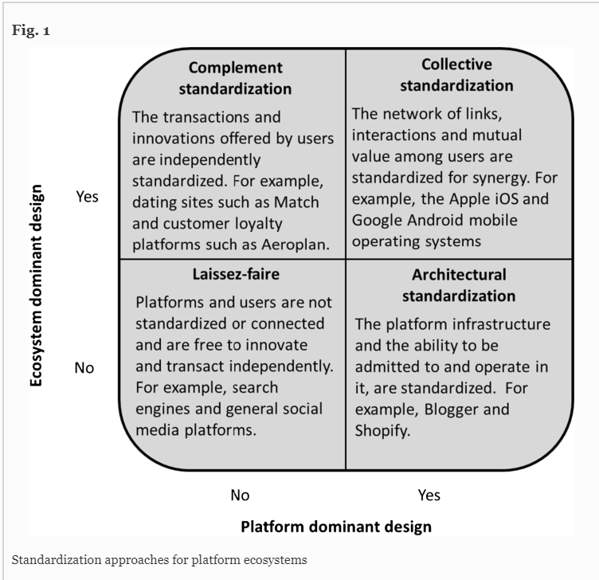

The two axes indicate the extent to which a platform (i.e., the X-axis) and an ecosystem of users of the platform (i.e., the Y-axis) have evolved to have dominant functionality, appearance, and modes of use. **With the Laissez-faire approach**, there is no standardization and associated dominant design, making it much like a traditional value chain where users search for or post calls for transactions. This approach includes the search engine Google and exchanges on social media sites. **With the Architectural approach,** there is a dominant platform design that hosts and supports users who build and offer transactions in customized ways. For example, Shopify is a dominant platform for helping merchants to develop and customize online stores in different industries and regions of the world. **The Complement approach** involves platforms with different business models and modes of use and appearance, but within an industry, they require highly standardized input and behavior from users. This approach includes loyalty card programs like Aeroplan and dating sites like Match. **The Collective approach** is when the platform and users' ecosystem are mutually dominant designs through standardization. The approach includes the Apple iOS and Google Android mobile operating systems. This approach helps ensure compatibility, interoperability, and quality of user transactions.

这两个轴表示平台（即 X 轴）和平台用户生态系统（即 Y 轴）已经发展到具有主导功能、外观和使用模式的程度。 **使用自由放任的方法**，没有标准化和相关的主导设计，使其很像传统的价值链，用户可以在其中搜索或发布交易请求。 这种方法包括搜索引擎 Google 和社交媒体网站上的交流。 **使用架构方法**，有一个占主导地位的平台设计来托管和支持以定制方式构建和提供交易的用户。 例如，Shopify 是帮助商家在全球不同行业和地区开发和定制在线商店的主导平台。 **互补方法**涉及具有不同商业模式和使用模式和外观的平台，但在一个行业内，它们需要高度标准化的用户输入和行为。 这种方法包括 Aeroplan 等会员卡计划和 Match 等约会网站。 **Collective 方法**是当平台和用户的生态系统通过标准化成为相互主导的设计时。 该方法包括 Apple iOS 和 Google Android 移动操作系统。 这种方法有助于确保兼容性、互操作性和用户事务的质量。

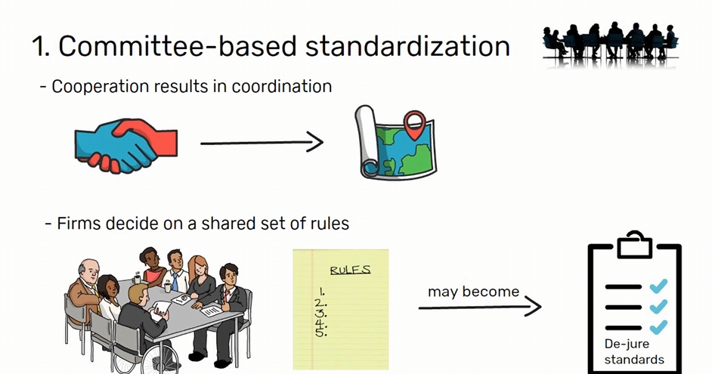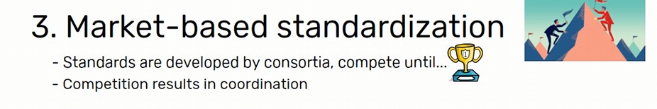

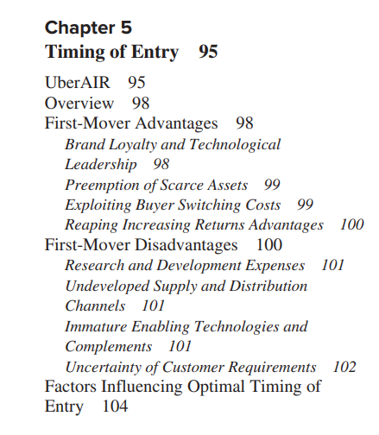

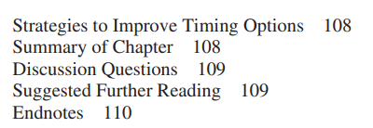

1. A first mover may be able to build brand loyalty and a reputation for technological leadership, preemptively capture scarce resources, and exploit buyer switching costs.

2. First movers may also benefit from increasing returns to adoption due to learning curve effects and network externalities.

3. Some studies, however, argue that first movers may have higher failure rates. First movers have to bear the brunt of R&D expenses and may face considerable consumer ambiguity. Second movers can capitalize on the R&D and marketing efforts of the first mover, producing a technology that costs less to develop and that corrects for any of the first mover’s mistakes. 4. First movers may also face poorly developed supplier markets, distribution channels, and availability of complementary goods, all of which can increase the challenge of successfully launching their new product or service. Enabling technologies may also be immature, hindering the new technology’s performance.

5. The biggest disadvantage many first movers face is uncertainty over customer requirements. Customers themselves may be uncertain about what features or form they desire in a new innovation. A firm may have to withstand significant losses before customer preferences become more certain.

6. The optimal timing of entry is thus a function of several factors, including the margin of advantage offered by the new innovation, the state of enabling technologies and complements, the state of customer expectations, the threat of competitive entry, whether the industry faces increasing returns, and a firm’s resources.

7. Firms that have fast-cycle development processes have more options when it comes to timing. Not only does a fast-cycle developer have an advantage in introducing innovations earlier, but it also can be its own fast follower by quickly introducing refined versions of its own technology.

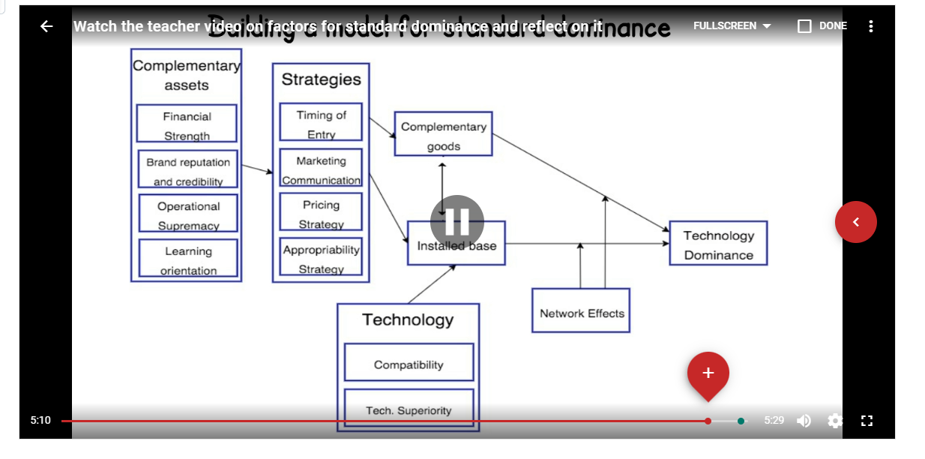

Factors for winning interface format battles: A review and synthesis of the literature

Geerten van de Kaa a, Jan van den Ende b, Henk J. de Vries b, Eric van Heck b

Our study focuses on interface formats which can be seen as compatibility standards. To which extent our findings also apply to other standards might be a topic of future research. A limitation of this study is that we focus on the influence of individual factors on format dominance though in format battles a set of interrelated factors can affect dominance. Schilling [[5]](https://www.sciencedirect.com/science/article/pii/S0040162511000631?via%3Dihub" \l "bb0025) for instance showed that the current installed base and the availability of complementary goods reinforce each other. **Also, environmental factors can moderate the influence of some firm-level factors.** For example, when a market is characterized by network externalities, **the format that has a higher installed base than its competitor has a higher chance of achieving dominance**[[4]](https://www.sciencedirect.com/science/article/pii/S0040162511000631?via%3Dihub" \l "bb0020). Studying format battles through case studies could reveal other possible combinations of factors for dominance. Furthermore, a practical limitation exists with respect to the applicability of the framework as a checklist in the [decision making process](https://www.sciencedirect.com/topics/psychology/decision-making-process). **Theoretically, if every firm that participates in the battle applied the framework, the competitive advantage for the individual firm could decrease to a negligible level. However, at the same time, the uncertainty with respect to which format will win is reduced, leading to a higher speed and likelihood of format dominance.**

我们的研究集中在可以被看作是兼容性标准的界面格式上。我们的研究结果在多大程度上也适用于其他标准，这可能是未来研究的一个主题。本研究的一个局限性是，我们专注于单个因素对格式支配力的影响，尽管在格式之争中，一系列相互关联的因素会影响支配力。例如，Schilling[5]表明，当前的安装基础和互补商品的可用性会相互加强。**另外，环境因素也可以缓和一些公司层面因素的影响。例如，当一个市场以网络外部性为特征时，拥有比其竞争对手更高的安装基础的格式有更大的机会实现支配地位[4]。**通过案例研究来研究格式之争可以发现其他可能的主导地位的因素组合。此外，在决策过程中，该框架作为检查表的适用性存在一个实际限制。**从理论上讲，如果每个参与战斗的公司都应用该框架，那么单个公司的竞争优势可能会减少到可以忽略不计的程度。然而，与此同时，关于哪种形式会获胜的不确定性也会减少，从而导致更高的速度和形式主导的可能性。**

* Shapiro, C., & Varian, H. R. (1999). The art of standards wars. California Management Review, 41(2), 8-32.

Before you can craft standards strategy, you first need to understand what type of standards war you are waging. The single most important factor to track is the compatibility between the dueling new technologies and established products. **Standards wars come in three types: Rival Evolutions, Rival Revolutions, and Revolution versus Evolution.**

Strength in the standards game is determined by ownership of seven critical assets:

• **control of an installed base**

**• intellectual property rights**

**• ability to innovate**

**• first-mover advantages**

**• manufacturing abilities**

**• presence in complementary products**

**• brand name and reputation**

Our main lessons for strategy and tactics, drawn from dozens of standards wars over the past century and more, are these:

• **Before you go to war, assemble allies. You'll need the support of consumers, suppliers of complements, and even your competitors.** Not even the strongest companies can afford to go it alone in a standards war.

• **Preemption is a critical tactic during a standards war.** Rapid design cycles, early deals with pivotal customers, and penetration pricing are the building blocks of a preemption strategy.

• Managing consumer expectations is crucial in network markets. Your goal is to convince customers—and your complementors—that you will emerge as the victor. Such expectations can easily become a self-fulfilling prophecy **when network effects are strong.** **To manage expectations you should engage in aggressive marketing, make early announcements of new products, assemble allies, and make visible commitments to your technology.**

• When you 've won your war, don't rest easy. Cater to your own installed base and avoid complacency. **Don't let the desire for backward compatibility hobble your ability to improve your product; doing so will leave you open to an entrant offering less compatibility but superior performance.** Commoditize complementary products to make your systems more attractive for consumers.

• If you fall behind, avoid survival pricing; it just signals weakness. A better tactic is to establish a compelling performance advantage, or to interconnect with the prevailing standard using converters and adapters.

在制定标准战略之前，您首先需要了解您正在进行的是哪种类型的标准战争。 要跟踪的最重要的一个因素是对决新技术与现有产品之间的兼容性。 **标准战争分为三种类型：竞争演化、竞争革命和革命对演化。**

标准游戏的实力取决于七项关键资产的所有权：

• **控制安装基础**

**• 知识产权**

**• 创新能力**

**• 先发优势**

**• 制造能力**

**• 存在于互补产品中**

**• 品牌名称和声誉**

我们从过去一个多世纪的数十场标准战争中吸取的战略和战术的主要教训是：

• **开战前，召集盟友。 您需要消费者、互补品供应商甚至竞争对手的支持。** 即使是最强大的公司也无法在标准战争中单打独斗。

• **先发制人是标准战争中的关键策略。** 快速的设计周期、与关键客户的早期交易以及渗透定价是抢先战略的基石。

• 管理消费者期望在网络市场中至关重要。 你的目标是让客户和你的互补者相信你会成为胜利者。 **当网络效应很强时，**这种期望很容易成为自我实现的预言。 **要管理期望，您应该进行积极的营销、尽早发布新产品、召集盟友并对您的技术做出明显的承诺。**

• 赢得战争后，不要高枕无忧。 迎合您自己的客户群，避免自满。 **不要让向后兼容的愿望阻碍您改进产品的能力； 这样做会让您对兼容性较低但性能卓越的参赛者敞开大门。** 将互补产品商品化，使您的系统对消费者更具吸引力。

• 如果你落后了，避免生存定价； 这只是软弱的信号。 更好的策略是建立引人注目的性能优势，或者使用转换器和适配器与现行标准互连。

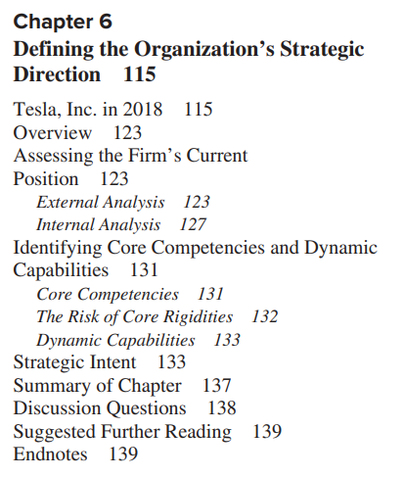

1. The first step in establishing a coherent strategy for the firm is assessing the external environment. Two commonly used models of external analysis are Porter’s five-force model and stakeholder analysis.

2. Porter’s five-force model entails assessing the degree of existing rivalry, threat of potential entrants, bargaining power of suppliers, bargaining power of customers, and threat posed by substitutes. Recently Porter added a sixth force, the role of complements.

3. Stakeholder analysis involves identifying any entity with an interest in the firm, what it wants from the company, and what claims it can make on the company.

4. To analyze the internal environment, firms often begin by identifying strengths and weaknesses in each activity of the value chain. The firm can then identify which strengths have the potential to be a source of sustainable competitive advantage.

5. Next the firm identifies its core competencies. Core competencies are integrated combinations of abilities that distinguish the firm in the marketplace. Several core competencies may underlie each business unit, and several business units may draw upon the same core competency.

6. Sometimes core competencies can become core rigidities that limit the firm’s ability to respond to a changing environment.

7. Dynamic capabilities are competencies that enable a firm to quickly reconfigure the firm’s organizational structure or routines in response to change in the firm’s environment or opportunities.

8. A firm’s strategic intent is the articulation of an ambitious long-term (10 to 20 years out) goal or set of goals. The firm’s strategic intent should build upon and stretch its existing core competencies.

9. Once the firm articulates its strategic intent, managers should identify the resources and capabilities that the firm must develop or acquire to achieve its strategic intent.

10. The balanced scorecard is a measurement system that encourages the firm to consider its goals from multiple perspectives (financial, customer, business process, and innovation and learning) and establish measures that correspond to each of those perspectives.

1. Barney,  J. 1991, Firm Resources and Sustained Competitive Advantage, *Journal of Management*, 17(1): 99 – 120.

That the study of sources of sustained competitive advantage focuses on valu-able, rare, imperfectly imitable, and non-substitutable resource endowments doesnot suggest--as some population ecologists would have it (eg Hannan & Free-man, 1977)-- that managers are irrelevant in the study of such advantages. In fact,managers are important in this model, for it is managers that are able to understandand describe the economic performance potential of a firm's endowments. Without such managerial analyses, sustained competitive advantage is not likely. Thisis the case even though the skills needed to describe the rare, imperfectly imitable,and non-substitutable resources of a firm may themselves not be rarc, imperfectlyimitable,or non-substitutable.

Indeed, it may be the case that a manager or a managerial team is a firm re-source that has the potential for generating sustained competitive advantages. Theconditions under which this will be the case can be outlined using the frameworkpresented in Figure Two However, in the end, what becomes clear is that firmscannot expect to “purchase” sustained competitive advantages on open markets(Barney, 1986a, 1988; Wernerfelt, 1989) Rather, such advantages must be foundin the rare, imperfectly imitable, and non-substitutable resources already con-trolled by a firm (Dicrickx & Cool1989)

**Indeed, a resource-based model of sus.tained competitive advantage anticipates a more intimate integration of the organizational and the economic as a way to study sustained competitive advantage**

**Thus, the studyof sustained competitive advantage depends, in a critical way, on the resource en.dowments controlled by a firm.**

对持续竞争优势来源的研究侧重于有价值的、稀有的、不可完全模仿的和不可替代的资源禀赋并不表明——正如一些种群生态学家所认为的那样（例如 Hannan & Free-man，1977）—— 管理者与这些优势的研究无关。 **事实上，经理人在这个模型中很重要，因为正是经理人能够理解和描述公司禀赋的经济绩效潜力。 没有这样的管理分析，持续的竞争优势是不可能的。** 即使描述公司稀有、不可完全模仿和不可替代资源所需的技能本身可能不是稀有、不可完全模仿或不可替代的，情况也是如此。

**事实上，经理或管理团队可能是一种公司资源，有可能产生持续的竞争优势。** 可以使用图二所示的框架来概述出现这种情况的条件 然而，最终，企业不能指望在公开市场上“购买”持续的竞争优势（Barney，1986a，1988；Wernerfelt，1989） ) 相反，这种优势必须在公司已经控制的稀有、不可完全模仿和不可替代的资源中找到 (Dicrickx & Cool1989)

**事实上，基于资源的持续竞争优势模型预期组织和经济的更紧密结合，作为研究持续竞争优势的一种方式**

**因此，持续竞争优势的研究在很大程度上取决于企业控制的资源禀赋。**

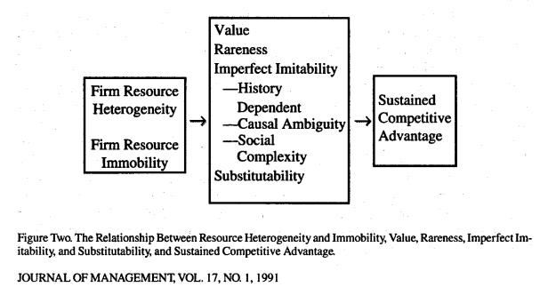

1. Barney, J. 2021, Resource-Based Theory and the Value Creation Framework, *Journal of Management*, 47(7): 1936 - 1955.

Building on this foundation, the article addresses several questions about resource-based theory:

**Is it a theory or a view?**

Others believe that it is clearly a theory, because it has suggested a wide variety of specific hypotheses that have been, and continue to be, tested. Moreover, it stacks up well to the criteria for theory offered in prominent discussions of theo- rizing such as Bacharach (1989), Sutton and Staw (1995), and Dubin (1978). the term theory would be more fitting

其他人则认为这显然是一种理论，因为它提出了各种各样的具体假设，这些假设已经并将继续得到检验。 此外，它与 Bacharach (1989)、Sutton 和 Staw (1995) 以及 Dubin (1978) 等著名的理论讨论中提供的理论标准非常吻合。认为术语理论更合适

**Is resource- based theory tautological?**

**Is resource-based theory static?**

**How important are stakeholders within resource-based theory?**

**Does resource-based theory constitute a theory of the firm?**

**Does resource-based theory acknowledge industry structure’s role in explaining firm performance?**

**Does resource-based theory incorporate uncertainty?**

**Does resource-based theory have strong managerial implications?**

在此基础上，本文解决了有关资源基础理论的几个问题：

是理论还是观点？

基于资源的理论是同义反复吗？

资源基础理论是静态的吗？

资源基础理论中的利益相关者有多重要？

资源基础理论是否构成企业理论？

资源基础理论是否承认产业结构在解释公司绩效方面的作用？

基于资源的理论是否包含不确定性？

基于资源的理论是否具有很强的管理意义？

1. 是理论还是观点？ 资源基础理论是一种理论，它提供了一个分析和理解企业竞争优势来源的框架。
2. 基于资源的理论是同义反复吗？ 通常来说，这个理论并不被认为是同义反复。它描述了一种情况，即当资源满足特定条件（如价值、稀有性、不可模仿性和不可替代性）时，这些资源可以为企业提供持久的竞争优势。
3. 资源基础理论是静态的吗？ 虽然资源基础理论重点关注的是企业的内部资源，但这并不意味着它是静态的。事实上，这个理论强调了企业需要不断地管理和更新其资源以保持竞争优势。
4. 在资源基础理论中，利益相关者有多重要？ 在这个理论中，利益相关者是非常重要的。他们可能影响企业的资源获取和使用，从而影响企业的竞争优势。
5. 资源基础理论是否构成一种企业理论？ 是的，资源基础理论是一种企业理论。它提供了一个框架，用于理解和分析企业如何通过其独特的资源和能力来获得竞争优势。
6. 资源基础理论是否承认行业结构在解释公司绩效中的重要性？ 虽然资源基础理论主要关注的是企业的内部资源，但它并不否认行业结构的重要性。它认识到行业结构可能会影响企业的竞争环境，从而影响其资源的使用和竞争优势的获得。
7. 基于资源的理论是否包含了不确定性的元素？ 是的，资源基础理论承认存在不确定性。特别是在考虑资源的获取和使用，以及这些如何转化为竞争优势时，都存在一定的不确定性。
8. 基于资源的理论是否具有强烈的管理意义？ 是的，资源基础理论为企业提供了一个重要的框架，用于理解和分析如何通过有效管理其独特的资源和能力来获得和保持竞争优势。
9. Lavie, D. 2006, The Competitive Advantage of Interconnected Firms: an Extension of the Resource Based View, *The Academy of Management Review*, 31(3): 638 – 658.

extend the resource-based view to incorporate the network resources of intercon nected firms. My model distinguishes shared resources from nonshared resources; identifies new types of rent; and illustrates how firm-, relation-, and partner-specific factors determine the contribution of network resources to the rents extracted from alliance networks. **After reassessing the heterogeneity, imperfect mobility, imitability, and substitutability conditions, I conclude that the nature of relationships may matter more than the nature of resources in networked environments.**

扩展基于资源的观点，以纳入相互关联的公司的网络资源。 我的模型将共享资源与非共享资源区分开来； 确定新的租金类型； 并说明公司、关系和合作伙伴特定因素如何决定网络资源对从联盟网络中提取的租金的贡献。 **在重新评估异质性、不完全流动性、可模仿性和可替代性条件后，我得出结论，在网络环境中，关系的性质可能比资源的性质更重要。**

Lavie extends RBV with alliance networks and shows:  
“....how an interconnected firm can extract value from resources that are not fully owned or controlled by its internal organization” (Lavie, 2006: p. 693)

Lavie 通过联盟网络扩展 RBV 并展示：“……相互关联的公司如何从其内部组织未完全拥有或控制的资源中提取价值”（Lavie，2006 年：第 693 页）



1. Firms often use a combination of quantitative and qualitative methods to evaluate which projects should be funded. Though some methods assume that all valuable projects will be funded, resources are typically constrained and firms must use capital rationing.

2. The most commonly used quantitative methods of evaluating projects are discounted cash flow methods such as net present value (NPV) or internal rate of return (IRR). While both methods enable the firm to create concrete estimates of returns of a project and account for the time value of money, the results are only as good as the cash flow estimates used in the analysis (which are often unreliable). Both methods also tend to heavily discount long-term or risky projects and can undervalue projects that have strategic implications that are not well reflected by cash flow estimates.

3. Some firms now use a real options approach to assess projects. Real options better account for the long-run strategic implications of a project. Unfortunately, many new product development investment decisions do not conform to the assumptions inherent in an options valuation approach.

4. One commonly used qualitative method of assessing development projects is to subject the project to a series of screening questions that consider the project from multiple angles. These questions may be used merely to structure the discussion of a project or to create rating scales that are then utilized in an approach that combines qualitative and quantitative assessment.

5. A company’s portfolio of projects typically includes projects of different types (e.g., advanced R&D, breakthrough, platform, and derivative projects) that have different resource requirements and different rates of return. Companies can use a project map to assess what their balance of projects is (or should be) and allocate resources accordingly.

6. Q-sort is a qualitative method of assessing projects whereby individuals rank each project under consideration according to a series of criteria. Q-sort is most commonly used to provide a format for discussion and debate.

7. Conjoint analysis is a method of converting qualitative assessments of a choice into quantitative weights of the different criteria underlying the choice. It is most often used for assessing how customers value different product attributes.

8. Data envelopment analysis (DEA) is another method that combines qualitative and quantitative measures. DEA enables projects that have multiple criteria in different measurement units to be ranked by comparing them to a hypothetical efficiency frontier.

The paper by Seelos and Mair provides 2 case studies of innovative products for bottom of the pyramid consumers by collaborating firms that try to find successful business models aimed at delivering on both value capturing and value creation. The British weekly the economist related in 2008 the discussion started by Prahalad and Hammond to the phenomenon of frugal innovations. Frugal innovations are designed or redesigned products services or systems that are produced at very low costs but without sacrificing user value. The two main characteristics are

• Affordability

• Being technologically achievable

1. C.K. Prahalad and Allen Hammond, 2002, Serving the World’s Poor, Profitably: Harvard Business Review 4-11.

Both of these scenarios are possible. Which one comes to pass will be determined primarily by one factor: the willingness of big, multinational companies to enter and invest in the world’s poorest markets. **By stimulating commerce and development at the bottom of the economic pyramid, MNCs could radically improve the lives of billions of people and help bring into being a more stable, less dangerous world. Achieving this goal does not require multinationals to spearhead global social development initiatives for charitable purposes. They need only act in their own self-interest, for there are enormous business benefits to be gained by entering developing markets.** In fact, many innovative companies—entrepreneurial outfits and large, established enterprises alike—are already serving the world’s poor in ways that generate strong revenues, lead to greater operating efficiencies, and uncover new sources of innovation. For these companies—and those that follow their lead—building businesses aimed at the bottom of the pyramid promises to provide important competitive advantages as the twenty-first century unfolds.

**Big companies are not going to solve the economic ills of developing countries by themselves, of course. It will also take targeted financial aid from the developed world and improvements in the governance of the developing nations themselves.** But it’s clear to us that prosperity can come to the poorest regions only through the direct and sustained involvement of multinational companies. And it’s equally clear that the multinationals can enhance their own prosperity in the process.

这两种情况都是可能的。 哪一个成为现实将主要取决于一个因素：大型跨国公司进入和投资世界上最贫穷市场的意愿。 **通过刺激经济金字塔底部的商业和发展，跨国公司可以从根本上改善数十亿人的生活，并帮助建立一个更稳定、危险更少的世界。** **实现这一目标并不需要跨国公司以慈善为目的带头开展全球社会发展计划。 他们只需要为自己的利益行事，因为进入发展中市场可以获得巨大的商业利益。** 事实上，许多创新公司——创业机构和大型老牌企业——已经在以产生可观收入、提高运营效率和发现新创新来源的方式为世界穷人服务。 对于这些公司——以及那些效仿它们的公司来说——以金字塔底部为目标开展业务有望在 21 世纪到来时提供重要的竞争优势。

**当然，大公司不会独自解决发展中国家的经济弊病。 它还将从发达国家获得有针对性的财政援助，并改善发展中国家自身的治理。** 但我们很清楚，只有通过跨国公司的直接和持续参与，最贫困地区才能实现繁荣。 同样清楚的是，跨国公司可以在此过程中增强自身的繁荣。

While individual incomes may be low, the aggregate buying power of poor communities is actually quite large.

虽然个人收入可能很低，但贫困社区的总购买力实际上相当大。

In reality, consumers at the bottom of the pyramid pay much higher prices for most things than middle-class consumers do, which means that there’s a real opportunity for companies, particularly big corporations with economies of scale and efficient supply chains, to capture market share by offering higher quality goods at lower prices while maintaining attractive margins.

实际上，金字塔底部的消费者为大多数东西支付的价格比中产阶级消费者高得多，这意味着公司，尤其是具有规模经济和高效供应链的大公司，确实有机会占领市场份额 通过以更低的价格提供更高质量的商品，同时保持有吸引力的利润。

The lesson for multinationals: Don’t hesitate to deploy advanced technologies at the bottom of the pyramid while, or even before, deploying them in advanced countries.

给跨国公司的教训是：在先进国家部署先进技术的同时，甚至在此之前，不要犹豫在金字塔底部部署先进技术。

We argue that when MNCs provide basic goods and services that reduce costs to the poor and help improve their standard of living—while generating an acceptable return on investment—the results benefit everyone.

我们认为，当跨国公司提供基本商品和服务以降低穷人的成本并帮助提高他们的生活水平时——同时产生可接受的投资回报——结果会使每个人受益。

The business opportunities at the bottom of the pyramid have not gone unnoticed. Over the last five years, we have seen nongovernmental organizations (NGOs), entrepreneurial start-ups, and a handful of forward-thinking multinationals conduct vigorous commercial experiments in poor communities. Their experience is a proof of concept: Businesses can gain three important advantages by serving the poor—a new source of revenue growth, greater efficiency, and access to innovation

金字塔底部的商机并没有被忽视。 在过去五年中，我们看到非政府组织 (NGO)、创业型初创企业和少数具有前瞻性思维的跨国公司在贫困社区进行了积极的商业试验。 他们的经验证明了这一概念：企业可以通过为穷人服务获得三个重要优势——收入增长的新来源、更高的效率和获得创新的机会。

**Markets at the bottom of the economic pyramid are fundamentally new sources of growth for multinationals. And because these markets are in the earliest stages, growth can be extremely rapid.**

处于经济金字塔底部的市场从根本上说是跨国公司增长的新来源。而且由于这些市场处于早期阶段，增长速度可能非常快。

In addition to expanding managers’ understanding of BOP markets, companies will need to make structural changes. To capitalize on the innovation potential of these markets, for example, they might set up R&D units in developing countries that are specifically focused on local opportunities.

除了扩大管理人员对国际收支市场的了解外，公司还需要进行结构性变革。 例如，为了利用这些市场的创新潜力，他们可能会在发展中国家设立专门关注当地机会的研发单位。

Making internal changes is important, but so is reaching out to external partners. Joining with businesses that are already established in these markets can be an effective entry strategy, since these companies will naturally understand the market dynamics better.

进行内部变革很重要，但接触外部合作伙伴也很重要。 加入已经在这些市场建立起来的企业可能是一种有效的进入策略，因为这些公司自然会更好地了解市场动态。

2. Scannel, J.W, A. Blanckley, H. Boldon and B. Warrington, 2012, Diagnosing the decline in pharmaceutical R&D efficiency, Nature Reviews, 11, 191 – 200.

However, in parallel — as many have discussed — R&D efficiency, measured simply in terms of the number of new drugs brought to market by the global bio- technology and pharmaceutical industries per billion US dollars of R&D spending, has declined fairly steadily24. We call this trend ‘Eroom’s Law’, in contrast to the more familiar Moore’s Law (‘Eroom’s Law’ is ‘Moore’s Law’ backwards).

然而，与此同时——正如许多人所讨论的那样——研发效率（仅根据全球生物技术和制药行业每 10 亿美元的研发支出推向市场的新药数量来衡量）已经相当稳定地下降 24。

Eroom’s Law indicates that powerful forces have outweighed scientific, technical and managerial improvements over the past 60 years, and\or that some of the improve- ments have been less ‘improving’ than com- monly thought. The more positive anyone is about the past several decades of progress, the more negative they should be about the strength of countervailing forces. If someone is optimistic about the prospects for R&D today, they presumably believe the countervailing forces — whatever they are — are starting to abate, or that there has been a sudden and unprecedented acceleration in scientific, technological or managerial progress that will soon become visible in new drug approvals.

Eroom 定律表明，在过去 60 年中，强大的力量已经超过了科学、技术和管理方面的进步，并且/或某些进步没有人们普遍认为的那么“进步”。 任何人对过去几十年的进步越是积极，他们对抵消力量的力量就越是消极。 如果有人对今天的研发前景持乐观态度，他们大概会相信抵消力量——无论它们是什么——正在开始减弱，或者科学、技术或管理进步突然出现前所未有的加速，很快就会在 新药审批。

Eroom's Law 是 Moore's Law 的逆转（即 Moore 的名字反过来写）。Moore's Law 描述的是计算能力每两年翻倍的趋势，即处理器性能与其价格的比值大约每两年提高一倍。相反，Eroom's Law 描述的是新药研发的效率在过去几十年里实际上下降了，即新药研发的成本每隔九年就翻一倍。

这一观察归因于研究者在医药科学中面临的挑战，包括研究复杂性的增加、监管压力的增加、以及有时在推动创新方面缺乏足够的激励机制。结果就是，尽管在药物研发上投入了大量的时间和资源，但我们看到的新药推出的速度实际上在减慢。

Christensen, C., M. Raynor and R, McDonald, 2015, What is Disruptive Innovation?, Harvard Business Review, December, p. 2 – 11.

Empirical tests show that using disruptive theory makes us measurably and significantly more accurate in our predictions of which fledgling businesses will succeed. As an ever-growing community of researchers and practitioners continues to build on disruption theory and integrate it with other perspectives, we will come to an even better understanding of what helps firms innovate successfully

实证检验表明，使用颠覆性理论可以使我们在预测哪些新兴企业将取得成功时显着更加准确。 随着越来越多的研究人员和从业人员继续建立颠覆理论并将其与其他观点相结合，我们将更好地理解什么有助于企业成功创新

The question now is whether there is a novel technology or business model that allows new entrants to move upmarket without emulating the incumbents’ high costs—that is, to follow a disruptive path. The answer seems to be yes, and the enabling innovation is online learning, which is becoming broadly available.

现在的问题是，是否有一种新技术或商业模式可以让新进入者在不效仿现有企业的高成本的情况下进入高端市场——也就是说，走一条颠覆性的道路。 答案似乎是肯定的，而促成创新的是在线学习，它正在变得广泛可用。

King, A.A. and Baatartogtokh, B., 2015, How Useful Is the Theory of Disruptive Innovation? MIT Sloan Management Review, 57-1, 76-92.

Before surveying and interviewing experts on each of the 77 cases, we identified four key elements of the theory of disruption:

* 1. that incumbents in a mar- ket are improving along a trajectory of sustaining innovation,

Usually, the sus- taining innovations improve the products in a few established value areas. For example, auto compa- nies might continue improving the horsepower or torque of their engines. As Christensen and Raynor explain, good managers strive “to make better prod- ucts that they can sell for higher profit margins to not-yet-satisfied customers in more demanding tiers of the market.”

* 1. that they overshoot customer needs,

A second element of Christensen and Raynor’s theory is that the pace of sustaining innovation along the trajectory of partic- ular value propositions “almost always outstrips the ability of customers in any given tier of the market to use it... Thus, a company whose products are squarely positioned on mainstream customers’ cur- rent needs will probably overshoot what those customers are able to utilize in the future.” 19 To illustrate their point, Christensen and Raynor use an example from the 1983 computer industry, “when people first started using personal computers for word processing. Typists often had to stop their fin- gers to let the Intel 286 chip inside catch up. ... But today’s processors offer much more speed than mainstream customers can use.”

* 1. that they possess the capability to respond to dis- ruptive threats, and

Incumbents have the capability to respond but fail to exploit it. Christensen and Raynor claim that incumbent companies frequently possess the capabilities needed to succeed, but managers fail to employ them effectively to combat potential disrup- tors

Although inferior when measured against the value propositions on which sustaining innovation has been focused, these disruptive products have other attributes: They are simpler, more convenient, and less expensive. Because an incumbent company’s existing activities “determine its perceptions of the economic value of an innovation [and] shape the rewards and threats,” Christensen and Raynor argue, managers fail to appreciate and address the potential threat. 24 If the disruption appears in a new market, incumbent businesses “ignore the attackers”; if among low-end customers, they “flee the attack.”

* 1. that incumbents end up floundering as a result of the disruption.

Companies with these disruptive technologies, he writes, “will always improve their products’ per- formance and in so doing eventually take over the older markets.” 28 “Once the disruptive product gains a foothold in new or low-end markets,” Chris- tensen and Raynor write, “the disruptors are on a path that will ultimately crush the incumbents.”2

在对 77 个案例中的每一个案例进行调查和采访专家之前，我们确定了颠覆理论的四个关键要素：

1市场中的现有企业正在沿着持续创新的轨迹改进，

通常，持续性创新会在一些既定的价值领域改进产品。 例如，汽车公司可能会继续提高其发动机的马力或扭矩。 正如 Christensen 和 Raynor 解释的那样，优秀的管理者努力“制造更好的产品，以更高的利润率出售给要求更高的市场层次中尚未满足的客户。

(2) 他们超越了客户需求 ，

Christensen 和 Raynor 理论的第二个要素是，沿着特定价值主张的轨迹持续创新的步伐“几乎总是超过任何给定市场层级的客户使用它的能力。 ……因此，如果一家公司的产品直接定位于主流客户的当前需求，那么它很可能会超出这些客户未来能够使用的范围。” 19 为了说明他们的观点，Christensen 和 Raynor 举了 1983 年计算机行业的一个例子，“当时人们第一次开始使用个人电脑进行文字处理。 打字员常常不得不停下手指，让内部的 Intel 286 芯片跟上。 ......但今天的处理器提供的速度比主流客户可以使用的速度快得多。”

（3）他们拥有应对破坏性威胁的能力，以及

现任者有能力做出回应，但未能加以利用。 Christensen 和 Raynor 声称，现任公司通常拥有成功所需的能力，但管理人员未能有效地利用这些能力来对抗潜在的颠覆者。

尽管与持续创新所关注的价值主张相比，这些颠覆性产品的表现不佳，但它们具有其他属性：它们更简单、更方便且成本更低。 Christensen 和 Raynor 认为，由于现有公司的现有活动“决定了它对创新经济价值的看法 [并] 塑造了回报和威胁”，因此经理们未能意识到并解决潜在的威胁。 24 如果颠覆出现在新市场，现有企业“无视攻击者”； 如果在低端客户中，他们会“逃避攻击”。

（4）现任者最终因破坏而陷入困境。

他写道，拥有这些颠覆性技术的公司“将始终提高其产品的性能，并最终接管旧市场。” 28“一旦颠覆性产品在新市场或低端市场站稳脚跟，”Christensen 和 Raynor 写道，“颠覆者将走上一条最终将碾压现有企业的道路。”2

Seelos, M. and J. Mair, 2007, Profitable Business Models and Market Creation in the Context of Deep Poverty: A Strategic View, *Academy of Management Perspectives*, November, p. 49 – 63.

The bottom of the pyramid (BOP) in the global distribution of income has been promoted as a significant opportunity for companies to grow profitably. Under the BOP approach, poor people are identified as potential customers who can be served if companies learn to fundamentally rethink their existing strategies and business models.

In our view, existing capabilities and existing local BOP models can be leveraged to build new markets that include the poor and generate sufficient financial returns for companies to justify investments

全球收入分配中的金字塔底部 (BOP) 已被提升为公司盈利增长的重要机会。 在 BOP 方法下，穷人被确定为潜在客户，如果公司学会从根本上重新考虑其现有战略和商业模式，他们就可以为他们提供服务。我们认为，可以利用现有能力和现有本地 BOP 模型来建立包括穷人在内的新市场，并为公司产生足够的财务回报以证明投资的合理性

Companies, consultants, develop- ment agencies, and academics need to better un- derstand the success factors for companies operat- ing in environments characterized by deep poverty.

公司、顾问、发展机构和学术界需要更好地了解在以极度贫困为特征的环境中运营的公司的成功因素。



1. A number of factors will influence whether a firm chooses to collaborate on an innovation. Some of the most important include whether the firm (or a potential partner) has the required capabilities or other resources, the degree to which collaboration would make proprietary technologies vulnerable to expropriation by a potential competitor, the importance the firm places on controlling the development process and any innovation produced, and the role of the development project in building the firm’s own capabilities or permitting it to access another firm’s capabilities.

2. Firms may choose to avoid collaboration when they already possess the necessary capabilities and other resources in-house, they are worried about protecting proprietary technologies and controlling the development process, or they prefer to build capabilities in-house rather than access a partner firm’s capabilities.

3. Some of the advantages of collaboration include sharing costs and risks of development, combining complementary skills and resources, enabling the transfer of knowledge between firms and the joint creation of new knowledge, and facilitating the creation of shared standards.

4. The term strategic alliances refers to a broad class of collaboration activities that may range from highly structured (e.g., joint ventures) to informal. Strategic alliances can enable simple pooling of complementary resources for a particular project, or they may enable the transfer of capabilities between partners. The transfer of capabilities often requires extensive coordination and cooperation.

5. A joint venture is a partnership between firms that entails a significant equity investment and often results in the creation of a new separate entity. Joint ventures are usually designed to enable partners to share the costs and risks of a project, and they have great potential for pooling or transferring capabilities between firms.

6. Licensing involves the selling of rights to use a particular technology (or other resource) from a licensor to a licensee. Licensing is a fast way of accessing (for the licensee) or leveraging (for the licensor) a technology, but offers little opportunity for the development of new capabilities.

7. Outsourcing enables a firm to rapidly access another firm’s expertise, scale, or other advantages. Firms might outsource particular activities so that they can avoid the fixed asset commitment of performing those activities in-house. Outsourcing can give a firm more flexibility and enable it to focus on its core competencies. Overreliance on outsourcing, however, can make the firm hollow.

8. Groups of organizations may form collective research organizations to jointly work on advanced research projects that are particularly large or risky.

9. Each form of collaboration mode poses a different set of trade-offs in terms of speed, cost, control, potential for leveraging existing competencies, potential for developing new competencies, or potential for accessing another firm’s competencies. An organization should evaluate these trade-offs in formulating a collaboration strategy.

10. Successful collaboration requires choosing partners that have both a resource fit and a strategic fit.

11. Successful collaboration also requires developing clear and flexible monitoring and governance mechanisms to ensure that partners understand their rights and obligations, and have methods of evaluating and enforcing each partner’s adherence to these rights and obligations

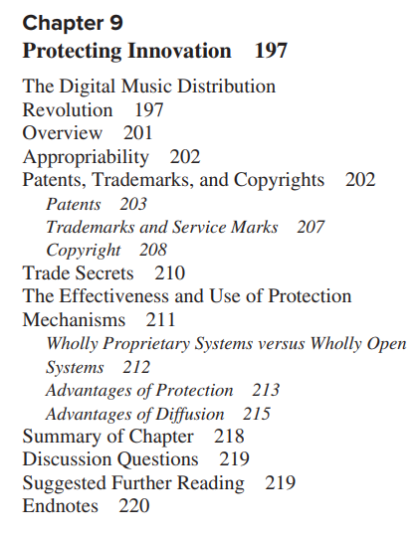

1. The degree to which a firm can capture the rents from its innovation efforts is largely determined by the degree to which competitors can quickly and easily imitate the innovation. Some innovations are inherently difficult to copy; others are difficult to copy because of the mechanisms the firm uses to protect its innovation.

2. The three primary legal mechanisms used to protect innovation in most countries are patents, trademarks, and copyrights. Each mechanism is designed to protect a different type of work or good.

3. International treaties have helped to harmonize patent, trademark, and copyright laws around the world. Most countries now have patent, trademark, and copyright laws of some form, and in some instances protection can be applied for in multiple countries simultaneously. 4. Trade secrets provide another mechanism of protecting innovation. Firms that protect their intellectual property as a trade secret often have legal recourse if another party wrongfully takes and uses such property.

5. Legal mechanisms for protecting innovation are more effective in some industries than others; in some industries, inventing around a patent or copyright is relatively easy. Similarly, in some industries, it is nearly impossible to protect an innovation by using trade secrets because commercializing the innovation reveals its underlying technologies.

6. Sometimes the choice between protecting versus diffusing a technology is not obvious. Both strategies offer potential advantages. Many firms use neither a wholly open nor a wholly proprietary strategy, but rather a partially open strategy.

7. Protecting an innovation helps ensure that the firm earns the lion’s share of the returns from the innovation. These returns can then be reinvested in further developing the technology, promoting the technology, and producing complementary goods.

8. Protecting an innovation also preserves the firm’s architectural control, enabling it to direct the technology’s development, determine its compatibility with other goods, and prevent multiple incompatible versions of the technology from being produced by other firms.

9. Diffusing a technological innovation can encourage multiple firms to produce, distribute, and promote the technology, possibly accelerating its development and diffusion. Diffusion can be particularly useful in industries that accrue increasing returns to adoption. It is also useful when the firm has inadequate resources to be the sole developer, producer, distributor, and marketer of a good.

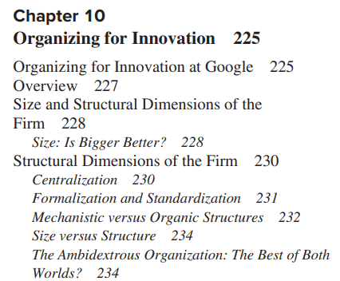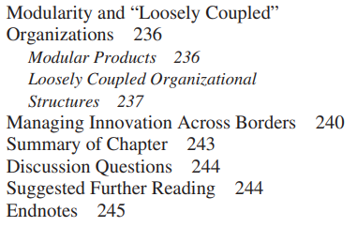

1. The impact of firm size on innovation has been debated for more than 50 years. Size is thought to confer advantages such as economies of scale in R&D, greater access to complementary resources (like capital and market access), and learning benefits. However, size may also be associated with disadvantages such as inertia and governance problems.

2. Many firms attempt to make big companies feel small by breaking them into networks of more specialized divisions. These divisions can behave like smaller, more entrepreneurial firms. 3. Structural dimensions of the firm, including formalization, standardization, and centralization, also affect the firm’s propensity to innovate and its effectiveness at innovation. Formalization and standardization tend to improve efficiency, but can stifle experimentation and creativity. Centralization has a more ambiguous effect on innovation; in some cases, centralization can enable significant innovation to occur more rapidly, and in other situations, decentralization fosters more innovation by enabling managers to respond quickly to local needs.

4. Traditionally, scholars have divided organization structures into two major types: mechanistic structures, which are highly formalized and standardized, and are good for efficient production, and organic structures, which are loose and free flowing and are good for creativity and experimentation.

5. Ambidextrous organizations attempt to achieve both the efficiency advantages of large mechanistic firms and the creativity and entrepreneurial spirit of small organic firms. These firms may have divisions with different structures and control schemes, or they may alternate between different structures.

6. Recently, many firms have begun forming loosely coupled networks both within and between firms to conduct development activities. Part of this transition is attributed to the rise in information technology and the resultant decrease in coordination costs.

7. Multinational firms face significant challenges in determining where and how to conduct their R&D activities. One primary challenge is to balance the need to tap the knowledge and resources of local markets while also achieving coherence across the corporation and ensure that technological innovations are diffused and leveraged throughout the organization.

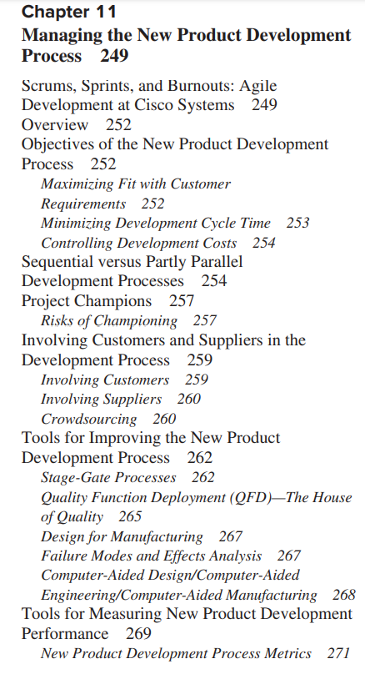

1. Successful new product development requires achieving three simultaneous objectives: maximizing fit with customer requirements, minimizing time to market, and controlling development costs.

2. Many firms have adopted parallel development processes to shorten the development cycle time and to increase coordination among functions such as R&D, marketing, and manufacturing.

3. Many firms have also begun using project champions to help ensure a project’s momentum and improve its access to key resources. Use of champions also has its risks, however, including escalating commitment and unwillingness of others in the organization to challenge the project.

4. Involving customers in the development process can help a firm ensure that its new products match customer expectations. In particular, research indicates that involving lead users can help the firm understand what needs are most important to customers, helping the firm to identify its development priorities. Involving lead users in the development process can also be faster and cheaper than involving a random sample of customers in the development process.

5. Many firms use beta testing to get customer feedback, exploit external development of the product, and signal the market about the firm’s upcoming products.

6. Firms can also involve suppliers in the development process, helping to minimize the input cost of a new product design and improving the likelihood that inputs are of appropriate quality and arrive on time.

7. Stage-gate processes offer a blueprint for guiding firms through the new product development process, providing a series of go/kill gates where the firm must decide if the project should be continued and how its activities should be prioritized.

8. Quality function deployment can be used to improve the development team’s understanding of the relationship between customer requirements and engineering attributes. It can also be a tool for improving communication between the various functions involved in the development process.

9. Failure Modes and Effects Analysis can be used to help firms prioritize their development efforts in order to reduce the likelihood of failures that will have the greatest impact on the quality, reliability, and safety of a product or process.

10. Design for manufacturing and CAD/CAM are additional tools development teams can use to reduce cycle time, improve product quality, and control development costs.

11. Firms should use a variety of measures of their new product development effectiveness and overall innovation performance to identify opportunities for improving the new product development process and improving the allocation of resources.

* Cheah, H-B. 1990. Schumpeterian and Austrian Entrepreneurship: Unity within duality. Journal of Business Venturing, Vol. 5, pp. 341-347.

SCHUMPETER’S CONCEPTION OF ENTREPRENEURSHIP

Schumpeter perceived the entrepreneur to be an extraordinary person who promotes “new combinations” or innovations. He noted that

**the function of entrepreneurs is to reform or revolutionize the pattern of production by exploiting an invention or, more generally, an untried technological possibility for pro- ducing an new commodity or producing an old one in a new way by opening up a new source of supply of materials or a new outlet for products, or by reorganizing an industry and so on** This kind of activity is primarily responsible for the recurrent “prosperities” that revolutionize the economics organism and the recurrent “recessions” that are due to the disequilibrating impact of the new products or methods. To undertake such new things is difficult and constitutes a distinct economic function, first, because they lie outside of the routine tasks which resist in many ways from simple refusal either to finance or to buy a new thing, to physical attack on the man who tries to produce it. To act with confidence beyond the range of familiar beacons and to overcome the resistance requires aptitudes that are present in only a small fraction of the population and that define the entrepreneurial type as well as the entrepreneurial function (Schumpeter 1950)

Such innovative efforts, which revolutionize the existing situation, are, for Schumpeter, an aspect of the process of “creative destruction” in capitalism. However, owing to the inherent uncertainties in the development process, it was also clear to Schumpeter that, in addition to technical skills and expertise, the exercise of intuition and strategy was of particular importance (Schumpeter 1934). At the same time, Schumpeter’s conception of strategy is different from Robbinsian economizing efforts oriented towards utility maximi- zation (Robbins 1935)

熊彼特的企业家精神

熊彼特认为企业家是推动“新组合”或创新的非凡人物。 他指出

**企业家的功能是通过开发一项发明或更普遍地说，开发一种未经尝试的生产新商品或以新方式生产旧商品的技术可能性，来改革或革新生产模式，开辟材料的新供应来源或产品的新出口，或者重新组织行业等。**这种活动主要负责反复引起的“繁荣”，这些繁荣革新了经济体系，以及由新产品或方法的失衡影响引起的反复出现的“衰退”。进行这样的新事物是困难的，并构成了一个明确的经济功能，首先，因为它们超出了日常任务的范围，而日常任务会以多种方式抵制，从简单地拒绝财务或购买新事物，到对尝试生产新事物的人进行物理攻击。要**在熟悉的信标范围之外自信地行动，并克服抵抗，需要一些只在人口的一小部分中存在的才能，这些才能定义了企业家类型以及企业家功能（熊彼特 1950年）。**

对于熊彼特来说，这种彻底改变现有状况的创新努力是资本主义“创造性破坏”过程的一个方面。 然而，由于开发过程中固有的不确定性，熊彼特也很清楚，除了技术技能和专业知识外，直觉和策略的运用也尤为重要（熊彼特 1934）。 同时，熊彼特的战略概念不同于罗宾斯的以效用最大化为导向的节约努力（Robbins 1935）

However, it would also be important to emphasize that even if it were possible to distinguish some individuals as being predominantly either Schumpeterian or Austrian en- trepreneurs, not all persons can be so neatly classified. One reason, emphasized by Drucker (1985, p. 26), is that entrepreneurship is a form of behavior rather than a personality trait. Behavior can be learned and, thus, changed. Second, Schumpeter (1939, p. 103) had pointed out that “it is not always easy to tell who the entrepreneur is in a given case. . . . Nobody is ever an entrepreneur ail the time, and nobody can ever be only an entrepreneur. This follows from the nature of the function, which must always be combined with, and lead to, others. ” Thus, in many cases, real individuals (and also processes, strategies, and organi- zations) could manifest some combination of the qualities of these two entrepreneurial modes, either simultaneously or sequentially. A further complicating factor is that, partly because of the possible unintended con- sequences of human action, it is difficult in many cases to determine ex ante whether an innovation would be a Schumpeterian or an Austrian innovation and, in both cases, whether it would be successful. These factors contribute to the complex character of the phenomenon. However, many of the empirical studies in this field fail to take these considerations into account

然而，同样重要的是要强调，即使有可能将某些人区分为主要是熊彼特式或奥地利式企业家，但并非所有人都可以如此整齐地分类。 德鲁克 (1985, p. 26) 强调的一个原因是，企业家精神是一种行为形式，而不是一种人格特质。 行为是可以学习的，因此可以改变。 其次，熊彼特 (Schumpeter, 1939, p. 103) 曾指出，“在给定的案例中，**要分辨谁是企业家并不总是那么容易。 . . . 没有人永远是企业家，也没有人永远只能是企业家。 这是根据功能的性质得出的，它必须始终与其他功能结合并导致其他功能。** 因此，在许多情况下，真实的个人（以及流程、战略和组织）可以同时或依次表现出这两种创业模式的某种品质组合。 **一个更复杂的因素是，部分由于人类行为可能产生意想不到的后果，在许多情况下很难事前确定一项创新是熊彼特式的还是奥地利式的创新，并且在这两种情况下，它是否会 成功的。 这些因素导致了这一现象的复杂性。** 然而，该领域的许多实证研究都没有考虑到这些因素

Despite agreement on some points, there was a significant difference of opinion between Schumpeter and his Austrian critics. These differences can be transcended by conceiving of two modes of entrepreneurship that can be termed as Schumpeterian (S) and Austrian (A) entrepreneurship. **Schumpeterian entrepreneurship promotes disequilibrium**; Schumpeterian entrepre- neurs promote the change of an existing situation. Their activities result in major innovations and even systematic changes, generating new development processes that create and/or widen the (e.g., technological) gap between leaders and followers. **In contrast, Austrian entrepreneurship promotes equilibrium;** Austrian entrepreneurs promote changes within an existing situation. Austrian entrepreneurship stems from the discovery of the existence of profitable discrepancies, gaps, and mismatches in knowledge and information that others have not yet perceived and exploited, and the entrepreneur acts to capitalize upon the opportunity for gain or advantage which that discovery presents. These activities increase knowledge about the situation, reduce the general level of uncertainty over time, and promote market processes that help to reduce or eliminate the gap between leaders and followers. Instead of treating these as contradictory concepts between which we are forced to choose, **it would be more fruitful to perceive Schunpeterian and Austrian entrepreneurship (and their associated activities, opportunities, and processes) as opposites and yet comple- ments to each other**, just like the forces of the yin and the yang of Chinese philosophy and folklore (see Figure 1).

**尽管在某些观点上达成了一致，但熊彼特和他的奥地利学派批评者之间的意见存在重大差异。** 这些差异可以通过设想两种创业模式来超越，这两种模式可以称为熊彼特 (S) 和奥地利 (A) 创业。 **熊彼特式的企业家精神促进了不平衡**； 熊彼特式的企业家提倡改变现有状况。 他们的活动导致重大创新甚至系统性变化，产生新的发展过程，创造和/或扩大领导者和追随者之间的（例如，技术）差距。 相比之下，**奥地利的企业家精神促进了平衡**； 奥地利企业家在现有情况下推动变革。 奥地利企业家精神源于发现其他人尚未察觉和利用的知识和信息中存在可盈利的差异、差距和不匹配，并且企业家采取行动以利用该发现所带来的获得收益或优势的机会。 这些活动增加了对情况的了解，随着时间的推移降低了一般的不确定性水平，并促进了有助于减少或消除领导者与追随者之间差距的市场进程。 **与其将这些视为我们被迫在其中做出选择的相互矛盾的概念**，**不如将 Schunpeterian 和奥地利学派的企业家精神（及其相关活动、机会和过程）视为对立而又互为补充，**这样会更有成效，就像 中国哲学和民间传说的阴阳力量（见图 1）。

The distinction between Schumpeterian and Austrian entrepreneurs (as well as opportunities, activities, and processes) identifies the dual nature of entrepreneurship, and strengthens the theoretical foundation of the research in this field by linking it more closely to propositions that originate from Schumpeter and his Austrian critics. At the same time, it places the ideas of both Schumpeter and the Austrians in a better perspective. Consequently, we better appreciate the significant roles that the two different modes of entrepreneurship can play in the evolutionary development process. **This analysis also suggests that the distinction between Schumpeterian and Austrian entrepreneurs is sufficiently comprehensive to encompass all types of entrepreneurs, whether in small or large businesses, or in new ventures or established enterprises, as well as entrepreneurs.** While it is important to note the complicating factors cited above, and while the actual dynamics involved in each situation may vary because of special circumstances, we suggest that the general propositions arising from this analysis provide a useful, basic model of the entrepreneurial process

熊彼特和奥地利企业家（以及机会、活动和过程）之间的区别确定了企业家精神的双重性质，并通过将其与源自熊彼特及其奥地利学派的命题更紧密地联系起来，加强了该领域研究的理论基础 评论家。 同时，它更好地展示了熊彼特和奥地利学派的思想。 因此，我们更好地理解了两种不同的创业模式在进化发展过程中可以发挥的重要作用。 **这一分析还表明，熊彼特和奥地利企业家之间的区别足够全面，可以涵盖所有类型的企业家，无论是小型企业还是大型企业，无论是新企业还是老牌企业，以及企业家。** 虽然注意到上面提到的复杂因素很重要，并且由于特殊情况，每种情况所涉及的实际动态可能会有所不同，但我们建议从该分析中得出的一般命题提供了一个有用的创业过程的基本模型

* Fisher, G. 2012. Effectuation, Causation, and Bricolage: A Behavioral Comparison of Emerging Theories in Entrepreneurship Research. Entrepreneurship Theory and Practice, sept, 1019-1051.

This study provides a critical examination of how different theoretical perspectives in entrepreneurship research translate into individual behavior, and whether such behavior is evident in the creation and development of new ventures. Using an alternative templates research methodology, the behaviors underlying the theories of effectuation, causation, and bricolage are evaluated to see whether such behaviors are observable in case study data describing the early development of six new ventures. The analysis highlights behavioral similarities and differences between the various theoretical perspectives in entrepreneur- ship research, providing insight into how these perspectives contrast and complement one another, and how they could be integrated in future research

本研究对创业研究中的不同理论观点如何转化为个人行为，以及这种行为在新企业的创建和发展中是否明显进行了批判性检验。 使用另一种模板研究方法，对效应、因果关系和拼凑理论背后的行为进行评估，以了解在描述六家新企业早期发展的案例研究数据中是否可以观察到此类行为。 该分析突出了创业研究中各种理论观点之间的行为异同，提供了对这些观点如何相互对比和互补以及如何将它们整合到未来研究中的见解

For many years, the domain of entrepreneurship relied largely on theoretical ideas imported from other domains. Over the past decade, scholars have begun developing theories specific to the domain of entrepreneurship. Effectuation and entrepreneurial bricolage are two such theories. As we seek to establish theories of entrepreneurship, it is important to understand how they relate to one another and to the traditional models of entrepreneurship. Furthermore, it is useful to assess how the processes related to such theories are manifest in the behavior of entrepreneurs (Bird & Schjoedt, 2009). This paper adopts the alternate templates approach (Allison, 1971; Langley, 1999) to provide such a comparison. The advantage of the alternate templates approach is that it provides a platform for comparing theories in context and for relating theory to action. Instead of reviewing theoretical ideas in the abstract, one is able to assess the extent to which such ideas help explain behaviors captured in empirical data. **The analysis highlights how certain behaviors are consistent across the emerging theories in entrepreneurship research and, therefore, points to the common behavioral dimensions of effectuation and entrepreneurial bricolage.** **The analysis also suggests that the causal model of entrepreneurship—which is the model that is most often touted in business school classes (Sarasvathy, 2001)—may not effectively capture and reflect the actual behavior of entrepreneurs launching new ventures in a dynamic environment.** Where causal approaches to entrepreneurship are adopted, they are utilized in conjunction with behaviors associated with effectuation and bricolage. Therefore, at a minimum, the traditional model of entrepreneurship needs to be combined with the emerging models to explain how entrepreneurs behave in the process of launching new ventures. The emerging theories of entrepreneurship (effectuation and bricolage) appear to be similar in many respects and provide a basis for identifying and developing new propositions focusing on the relationships between resources, entrepreneurial opportunities, action, solutions, com- munities, resource constraints, and creativity that may further enrich entrepreneurship research.

多年来，创业领域在很大程度上依赖于从其他领域引进的理论思想。 在过去的十年中，学者们已经开始发展专门针对创业领域的理论。 Effectuation 和 entrepreneurial bricolage 就是两个这样的理论。 当我们寻求建立创业理论时，重要的是要了解它们之间的关系以及它们与传统创业模型的关系。 此外，评估与此类理论相关的过程如何体现在企业家的行为中也很有用（Bird & Schjoedt，2009）。 本文采用替代模板方法（Allison，1971；Langley，1999）来提供这样的比较。 替代模板方法的优点是它提供了一个平台，用于在上下文中比较理论并将理论与行动联系起来。 与其抽象地回顾理论思想，不如评估这些思想在多大程度上有助于解释实证数据中捕获的行为。 **该分析强调了某些行为在创业研究的新兴理论中是如何保持一致的，因此指出了实现和创业拼凑的共同行为维度。** **分析还表明，创业的因果模型——这是商学院课堂上最常吹捧的模型（Sarasvathy，2001 年）——可能无法有效地捕捉和反映企业家在动态环境中开展新企业的实际行为。** 在采用因果创业方法的情况下，它们与与实现和拼装相关的行为结合使用。 因此，至少需要将传统的创业模型与新兴模型相结合，以解释创业者在开展新企业过程中的行为方式。 新兴的创业理论（effectuation 和 bricolage）在许多方面似乎相似，并为识别和发展新命题提供了基础，这些命题侧重于资源、创业机会、行动、解决方案、社区、资源约束和创造力之间的关系 这可能会进一步丰富创业研究。

**Too many resources within an entrepreneurial enterprise may prompt a team to become comfortable and quell creativity. Entrepreneurial ventures may be better off if they are forced to operate within tight resource constraints.**

**创业企业内部的资源过多可能会促使团队变得舒适并扼杀创造力。 创业企业如果被迫在严格的资源限制下运作，可能会更好。**

* Stevenson, H.H., Gumpert, D. 1985. The heart of entrepreneurship. Harvard Business Review, 63(2): 85-94.

“It’s much easier and safer for companies to stay with the familiar than to explore the unknown,” assert the authors of this article. Staying with the familiar may have its dangers, however, in today’s fast-changing world. An injection of entrepreneurship, by which creative people are encouraged to strike out and come up with new products or services, may become important to the financial health of organizations.

“对于公司来说，留在熟悉的环境中比探索未知的事物要容易和安全得多，”这篇文章的作者断言。 然而，在当今瞬息万变的世界中，与熟悉的事物保持联系可能会带来危险。 注入企业家精神，鼓励有创造力的人出击并提出新产品或服务，这可能对组织的财务健康很重要。

But it’s safe to say that as managers move closer to the promoter end of the scale they become more entrepreneurial, and as they move toward the trustee end of the scale they become less so (or, perhaps, more administrative).

但可以肯定地说，当管理者越接近规模的发起人一端时，他们会变得更具企业家精神，而当他们越接近规模的受托人一端时，他们的创业精神就会减弱（或者，也许，更具管理性）。

The typical administrator asks:

What resources do I control?

What structure determines our organization’s relationship to its market?

How can I minimize the impact of others on my ability to perform?

What opportunity is appropriate?

The entrepreneur, at the other end of the spectrum, tends to ask: Where is the opportunity?

How do I capitalize on it?

What resources do I need?

How do I gain control over them?

What structure is best?

The impact of the difference in approach becomes apparent as we trace the entrepreneurial thought pattern.

典型的管理员会问：

我控制什么资源？

什么结构决定了我们组织与其市场的关系？

我如何才能最大限度地减少他人对我执行能力的影响？

什么机会合适？

在光谱的另一端，企业家往往会问：机会在哪里？

我该如何利用它？

我需要什么资源？

我如何获得对它们的控制权？

什么结构最好？

当我们追溯创业思维模式时，方法差异的影响变得显而易见。

* Blank, Steve. 2013. Why the lean start-up changes everything. Harvard Business Review. 91. 63-72.

But recently an important countervailing force has emerged, one that can make the process of starting a company less risky. It’s a methodology called the “lean start-up,” and it favors experimentation over elaborate planning, customer feedback over intuition, and iterative design over traditional “big design up front” development.

但最近出现了一种重要的抵消力量，一种可以降低创办公司过程风险的力量。 这是一种称为“精益创业”的方法，它更喜欢实验而不是精心策划，更喜欢客户反馈而不是直觉，以及迭代设计而不是传统的“预先大设计”开发。

One of the critical differences is that while existing companies execute a business model, start-ups look for one. This distinction is at the heart of the lean start-up approach. It shapes the lean definition of a start-up: a temporary organization designed to search for a repeatable and scalable business model. The lean method has three key principles: First, rather than engaging in months of planning and research, entrepreneurs accept that all they have on day one is a series of untested hypotheses—basically, good guesses. So instead of writing an intricate business plan, founders summarize their hypotheses in a framework called a business model canvas. Essentially, this is a diagram of how a company creates value for itself and its customers.

其中一个关键区别是，现有公司执行一种商业模式，而初创企业则寻找一种商业模式。 这种区别是精益创业方法的核心。 它塑造了初创企业的精益定义：一个临时组织，旨在寻找可重复和可扩展的商业模式。 精益方法具有三个关键原则：首先，与其进行数月的计划和研究，企业家接受他们在第一天所拥有的只是一系列未经检验的假设——基本上是好的猜测。 因此，创始人不是编写复杂的商业计划，而是在称为商业模型画布的框架中总结他们的假设。 从本质上讲，这是一张公司如何为自己和客户创造价值的图表。

Third, lean start-ups practice something called agile development, which originated in the software industry. Agile development works hand-in-hand with customer development. Unlike typical yearlong product development cycles that presuppose knowledge of customers’ problems and product needs, agile development eliminates wasted time and resources by developing the product iteratively and incrementally. It’s the process by which start-ups create the minimum viable products they test.

第三，精益创业实践一种叫做敏捷开发的东西，它起源于软件行业。 敏捷开发与客户开发密切相关。 与以了解客户问题和产品需求为前提的典型的长达一年的产品开发周期不同，敏捷开发通过迭代和增量开发产品来消除浪费的时间和资源。 这是初创企业创建他们测试的最低限度可行产品的过程。

Using lean methods across a portfolio of start-ups will result in fewer failures than using traditional methods. 在一系列初创企业中使用精益方法 将导致比使用传统方法更少的故障。

In the 21st century those forces will make people in every kind of organization—start-ups, small businesses, corporations, and government—feel the pressure of rapid change. The lean start-up approach will help them meet it head-on, innovate rapidly, and transform business as we know it.

在 21 世纪，这些力量将使各种组织（初创企业、小型企业、企业和政府）中的人们感受到快速变革的压力。 精益创业方法将帮助他们直面挑战、快速创新并实现我们所知的业务转型。

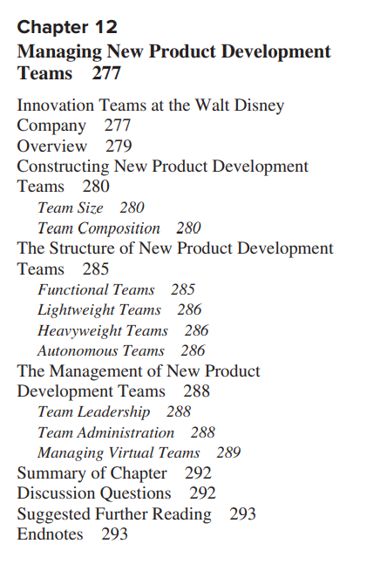

1. Bringing multiple people together into a team enables multiple bases of expertise to be collectively directed toward problem solving; thus, teams are powerful mechanisms for problem solving. However, if teams become too big, administrative costs and communication problems can become significant.

2. Diversity of team members ensures that the team can draw on different perspectives and bases of expertise. In particular, functional diversity is often sought in new product development teams. Cross-functional teams enable design, manufacturing, and marketing objectives to be integrated in the new product development process.

3. Diversity of team members ensures that the individuals in the team not only possess different knowledge or viewpoints, but also have different sources of extra-team resources upon which to draw through boundary-spanning activities.

4. Diversity can also make it more difficult for teams to develop a common understanding of the new product development project and can result in lower group cohesion. Teams may need long-term contact and incentives for cooperation to overcome these challenges.

5. The way in which a team is structured (collocation, permanence, supervisory relationships, etc.) significantly influences how team members interact and the likely outcomes of a development project. Different types of teams are appropriate for different types of development projects.

6. Attributes of the team leader (seniority, authority, multilingual skills) must match the team type for teams to be most effective.

7. Many firms have teams develop and sign a project charter and contract book to ensure that all team members have a common understanding of the project’s goals and possess a sense of ownership and commitment to the project’s success.

8. When a company wishes to form a team with individuals who have unique skills but live great distances from each other, it might opt to form a virtual team. Virtual teams use information technologies to achieve communication and coordination. Virtual teams face a distinct set of challenges in promoting participation, cooperation, and trust. As a result, they require special consideration of the selection of team members and the team administration processes.

Reagans, R., & Zuckerman, E.W. 2001. Networks, diversity, and productivity: The social capital of corporate R&D teams. Organizations Science, 12(4): 502-517

We have found support for such a view of social capital in our finding that R&D teams that have more dense networks of interaction achieve a higher level of productivity than do those with sparse networks.

我们发现，拥有更密集交互网络的研发团队比拥有稀疏网络的研发团队的生产力水平更高，我们发现支持这种社会资本观点。

However, we also find that teams that display greater levels of contact between individuals of the same organizational tenure are less productive than do teams that are characterized by links between members who entered the organization at different points in time.

然而，我们还发现，与在不同时间点进入组织的成员之间存在联系的团队相比，在相同组织任期的个人之间表现出更高水平接触的团队的生产力较低。

The latter results reflects the orientation of a second view on diversity, corresponding to a second perspective on social capital, which emphasizes the importance of inter- change among individuals with a wide range of skills, information, and experiences, for maximizing a group’s capacity for creativity and effective action.

后一结果反映了第二种关于多样性的观点的取向，对应于第二种关于社会资本的观点，它强调具有广泛技能、信息和经验的个人之间进行交流的重要性，以最大限度地提高群体的能力 创造力和有效的行动。

Finally, while we find that network heterogeneity in- creases productivity, it may be that extensive intercate- gory links have negative implications for other outcomes.

最后，虽然我们发现网络异质性提高了生产力，但广泛的类别间联系可能对其他结果有负面影响。

Thus, greater network heterogeneity may increase the level of conflict among members and thereby reduce its perfor- mance on outcomes other than productivity.

因此，更大的网络异质性可能会增加成员之间的冲突程度，从而降低其在生产率以外的结果上的表现。

O’Reilly, Charles .A. and Tushman, Michael L. 2004. The ambidextrous   organization. Harvard Business Review, April: 74-83.

We call these kinds of companies “ambidextrous organizations,” and we believe they provide a practical and proven model for forward-looking executives seeking to pioneer radical or disruptive innovations while pursuing incremental gains. A business does not have to escape its past, these cases show, to renew itself for the future.

我们将这类公司称为“灵巧的组织”，我们相信它们为寻求开拓激进或颠覆性创新同时追求增量收益的前瞻性高管提供了一个实用且经过验证的模型。 这些案例表明，企业为了未来而更新自己。

Ambidextrous organizations encompass two profoundly different types of businesses—those focused on exploiting existing capabilities for profit and those focused on exploring new opportunities for growth. As this table indicates, the two require very different strategies, structures, processes, and cultures.

双元型组织包含两种截然不同的业务类型——专注于利用现有能力获取利润的企业和专注于探索新增长机会的企业。 正如该表所示，两者需要截然不同的战略、结构、流程和文化。

Birkinshaw and Gibson 2004. Building ambidexterity into an organization. MIT Sloan Management Review, 45 (4), 47-55.

The concept of organizational ambidexterity has been around for years, but the evidence suggests that many companies have struggled to apply it. The standard approach is to create structural ambidexterity, that is, to create separate structures for different types of activities.2 For example, the core business units are given responsibility for creating alignment with the existing products and markets; and the R&D department and business development group are given the job of prospecting for new markets, developing new technologies and keeping track of emerging industry trends. Structural separation is necessary, the argument goes, because the two sets of activities are so dramatically different that they cannot effectively coexist.

组织二元化的概念已经存在多年，但有证据表明，许多公司一直在努力应用它。 标准方法是创建结构二元性，即为不同类型的活动创建单独的结构。2 例如，核心业务部门负责与现有产品和市场保持一致； 研发部和业务发展组负责开拓新市场、开发新技术和跟踪新兴行业趋势。 争论认为，结构分离是必要的，因为这两组活动截然不同，以至于它们无法有效共存。

But separation also can lead to isolation, and many R&D and business-development groups have failed to get their ideas accepted because of their lack of linkages to the core businesses. Many companies have experimented with variants of the structural ambidexterity model. Some pull individuals out of their current jobs to work in a dedicated cross-functional team for a limited period of time. Others separate the different types of activities within a single business unit — for example, they create a small business-development team attached to a business unit. These approaches avoid the extreme form of separation that is typical of dual structures. But they nonetheless remain top-down in nature in that they rely on business-unit managers to judge how best to divide employees’ time between one set of activities and another.

但分离也可能导致孤立，许多研发和业务开发团队由于缺乏与核心业务的联系而未能让他们的想法被接受。 许多公司已经尝试了结构二元化模型的变体。 有些人将个人从他们目前的工作中拉出来，在一个专门的跨职能团队中工作一段有限的时间。 其他人将不同类型的活动分隔在一个业务部门内——例如，他们创建了一个附属于业务部门的小型业务开发团队。 这些方法避免了双重结构典型的极端分离形式。 但它们本质上仍然是自上而下的，因为它们依靠业务部门经理来判断如何最好地将员工的时间分配给一组活动和另一组活动。

Contextual ambidexterity differs from structural ambidexterity in many important ways (see “Structural Ambidexterity vs. Contextual Ambidexterity”), but the two approaches are best viewed as complementary. Indeed, many successful companies, including Hewlett-Packard, 3M and Intel, use a combination of both approaches to deliver simultaneously on the needs for alignment and adaptability.

情境二元性在许多重要方面不同于结构性二元性（参见“结构性二元性与情境二元性”），但这两种方法最好被视为互补。 事实上，许多成功的公司，包括惠普、3M 和英特尔，都结合使用这两种方法来同时满足一致性和适应性的需求。

View contextual ambidexterity initiatives as “driving leadership,” not as being “leadership-driven.”

Ambidexterity arises not just through formal structure or through the vision statements of a charismatic leader. Rather, it is achieved in large part through the creation of a supportive context in which individuals make their own choices about how and where to focus their energies. Leadership, in other words, becomes a characteristic displayed by everyone in the organization.9 The impetus toward ambidexterity may sometimes be driven by top-down initiatives, but the goal is to allow leadership to emerge from the organization at all levels and for that ubiquitous, emergent leadership to be inherently ambidextrous.

将上下文二元性举措视为“推动领导力”，而不是“领导力驱动”。

双元性不仅仅来自于正式的结构或来自魅力型领导者的愿景陈述。 相反，它在很大程度上是通过创造一个支持性的环境来实现的，在这个环境中，个人可以自己选择如何以及在何处集中精力。 换句话说，领导力成为组织中每个人都表现出的特征。 9 双元化的动力有时可能是由自上而下的举措驱动的，但目标是让领导力从组织的各个层面出现，并让无处不在的领导力 ，新兴领导本质上是灵巧的。

View contextual ambidexterity and structural ambidexterity as complements.

Contextual ambidexterity isn’t an alternative to structural ambidexterity but rather a complement. Structural separation may at times be essential, but it should also be temporary, a means to give a new initiative the space and resources to get started. The eventual goal should be reintegration with the mainstream organization as quickly as possible. Contextual ambidexterity can enhance both the separation and reintegration processes.

将语境二元性与结构性二元性视为互补。

语境二元性不是结构性二元性的替代品，而是一种补充。 结构分离有时可能是必要的，但它也应该是暂时的，一种为新计划提供启动空间和资源的方法。 最终目标应该是尽快重新融入主流组织。 语境二元性可以加强分离和重新整合过程。

Kohler, T. 2016. Corporate accelerators Building bridges between corporations and startups.

Today’s startups are a major source of innovation, as they employ emerging technologies to invent products and reinvent business models. **Corporations that embrace an open innovation strategy increasingly look to startups as a source of external innovation.** **Corporate accelerators offer a potent approach to nurturing innovations from entrepreneurial ventures.** However, the vast differences between corporations and startups make collaboration a challenge. Corporate accelerators need to be designed effectively to add value for startups and create innovation benefits for the company. Based on information obtained during interviews with managers and participants of corporate accelerators (n=40), managers receive a framework and strategies for designing corporate accelerators. **To leverage startups’ innovation and to make corporate accelerators an effective part of a firm’s overall innovation strategy, managers need to systematically and thoughtfully consider the design dimensions of proposition, process, people, and place.**

当今的初创公司是创新的主要来源，因为它们采用新兴技术来发明产品和重塑商业模式。 **采用开放式创新战略的公司越来越多地将初创企业视为外部创新的来源。** **企业加速器提供了一种有效的方法来培育创业企业的创新。** 然而，企业和初创公司之间的巨大差异使协作成为一项挑战。 企业加速器需要有效设计，为初创企业增加价值，为公司创造创新效益。 根据在与企业加速器的经理和参与者 (n=40) 的访谈中获得的信息，经理们收到了设计企业加速器的框架和策略。 **为了利用初创公司的创新并使企业加速器成为公司整体创新战略的有效组成部分，管理者需要系统地、周到地考虑命题、流程、人员和地点的设计维度。**

Several limitations should be considered when de- signing corporate accelerators. Despite the poten- tial of corporate accelerators, challenges result from immense gaps in work practices, substantial cultural differences, and different organizational clocks (Weiblen & Chesbrough, 2015).

在设计企业加速器时应考虑几个限制。 尽管企业加速器具有潜力，但工作实践中的巨大差距、巨大的文化差异和不同的组织时钟带来了挑战（Weiblen & Chesbrough，2015 年）。

Being bound to a big corporation could limit start- ups’ freedom to pivot, and it is not always clear if the corporate accelerator has a hidden agenda that contradicts the startup’s goals.

受制于一家大公司可能会限制初创企业的转向自由，而且企业加速器是否有与初创企业目标相矛盾的隐藏议程并不总是很清楚。

Second, corporate involvement might stifle the progress of startups. In addition to achieving product—market fit, startups must achieve product—corporate fit in corporate accelerators; hence, they could end up with a fitted solution to one company’s challenges rather than building a scalable solution to a general industry problem.

其次，企业参与可能会扼杀初创企业的进步。 除了实现产品与市场的契合，初创企业还必须在企业加速器中实现产品与企业的契合； 因此，他们最终可能会针对一家公司的挑战找到合适的解决方案，而不是针对一般行业问题构建可扩展的解决方案。

Third, there is the risk of overprotection through corporate backing, which leads to depen- dency or increases the likelihood–—and sunk costs–— of later failure.

第三，存在通过企业支持过度保护的风险，这会导致依赖性或增加日后失败的可能性——以及沉没成本。

Effective corporate accelerators foster corporate innovation and offer valuable support for startups. Early examples of corporate accelerators do not represent the end of the story, but rather just the beginning. As startups look for ways to scale their ventures and corporations eagerly search for innova- tion, there will be more efforts to collaborate through corporate accelerators. With the framework described here, managers receive starting points to increase their chances of benefitting from the prom- ising possibilities of corporate accelerators.

有效的企业加速器促进企业创新并为初创企业提供宝贵的支持。 企业加速器的早期例子并不代表故事的结局，而只是一个开始。 随着初创公司寻找扩大风险的方法，以及企业急切寻求创新，将会有更多的努力通过企业加速器进行合作。 通过此处描述的框架，管理人员获得起点，以增加他们从企业加速器的有前途的可能性中获益的机会。

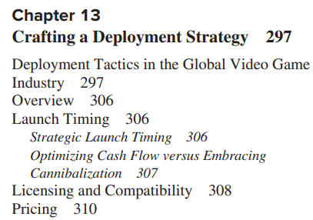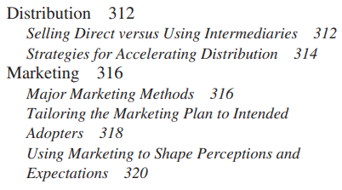

1. A firm can use its launch timing strategy to take advantage of business cycle or seasonal effects, to influence its positioning vis-à-vis competitors, and to ensure that production capacity and complementary goods are sufficiently available at time of launch.

2. The launch timing decision must also consider the need to harvest cash flows from existing product generations versus the advantages of willingly cannibalizing existing products to preempt competitors.

3. Successful deployment requires striking a careful balance between making a system open enough to attract complementary goods providers (and/or other producers if that is desirable) and protected enough to ensure that product quality, margins, and compatibility can be sustained.

4. Common pricing strategies for technological innovations include market skimming and penetration pricing. While the first attempts to maximize margins earned on early sales of the product, the second attempts to maximize market share. Pricing strategies should consider the firm’s ability to earn profits from sales of complementary goods or services—if profits from complements are expected to be high, lower prices on the platform technology may be warranted.

5. Firms can manipulate the customer’s perception of the product’s price (and the timing of cash flows) through the timing of when the price is paid.

6. Intermediaries provide a number of valuable roles in the supply chain, including breaking bulk, transporting, carrying inventory, providing selling services, and managing customer transactions.

7. Sometimes a firm can accelerate distribution of its innovation by forging relationships with distributors, bundling the good with others that have a wider installed base, sponsoring large customer groups, or providing sales guarantees to distributors or complements producers.

8. Marketing methods vary in attributes such as cost, reach, information content, duration of exposure, flexibility of message, and ability to target particular segments of the market. When designing the marketing plan, the firm must take into account both the nature of the innovation (e.g., Is it complex? Are benefits easy to observe?) and the nature of the customer (e.g., Does the customer require in-depth technical detail? Is the customer likely to be influenced by brand images and/or reputation? How much uncertainty is the customer likely to tolerate?).

9. Marketing strategies can influence the market’s perception of how widely used the product is or will be, and thus can influence the behavior of customers, distributors, and complementary goods producers. Preannouncements, the firm’s reputation, and credible commitments can all influence the market’s assessment of the product’s likelihood of success.

4 strategic misconception on frugal innovation

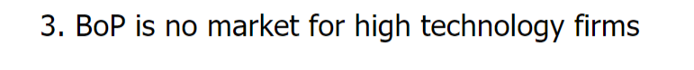4. Another big misperception about developing markets is that the goods sold there are incredibly cheap and, hence, there’s no room for a new competitor to come in and turn a profit.

Taylorism two main principles

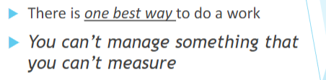

Environmental conditions for Taylorism

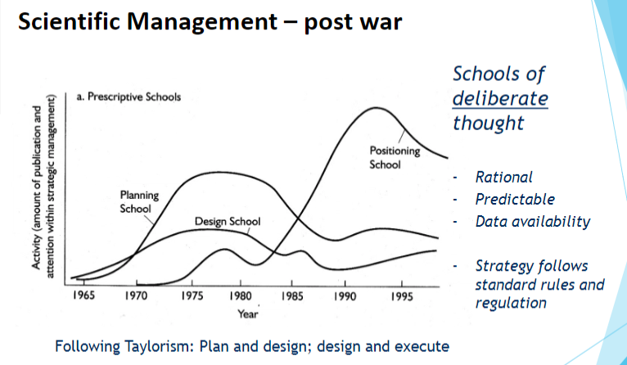

Under the assumption and features of Rational, Predictable and Data availability. The post war scientific management strategy follows standard rules and regulation. Plan and design; design and execute

How related to resource based theory

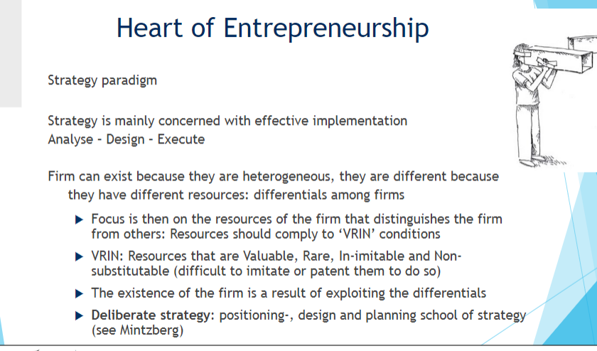

Knowledge Spillover requirement

